VOLUNTEER’S STAFFING FORM FOR 2018 NEWARK BEER FESTIVAL 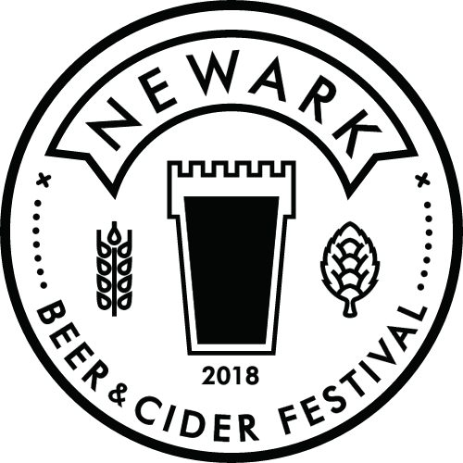

Shifts are allocated in blocks of 2 hours.
Beer tokens will be allocated in the usual way – 3 tokens per 2 hours worked.
After a 4 hour block you will receive a food voucher (maximum 2 per day)

NAME:

EMAIL:

PHONE:

CAMRA MEMBERSHIP NO:

Have you volunteered at the Newark Beer Festival before: YES: NO:

Please mark x in the boxes below for the time and dates of the shifts you would like to do.
The shifts on Sunday from 16:30 are to assist with the take down.
We also need help with the set up on Wed 23rd and Thur 24th May. Please mark x if you can help with this.
WED 23/05 1pm onwards - THURSDAY 24/05 9am onwards –

PLEASE NOTE: ANYONE HELPING WITH SET UP AND TAKE DOWN MUST WEAR STEEL TOE-CAPPED FOOTWEAR. Newark CAMRA will subsidise £15.00 per person to purchase a pair.

SHIFT HOURS | FRI 25/05 | SAT 26/05 | SUN 27/05
10:30 – 12:30
12:30 – 14:30
14:30 – 16:30
16:30 – 18:30
18:30 – 20:30 |  |  | Until 19:30.
20:30 – 22:30

Are you willing to work anywhere? - Beer bar, Cider bar, Tokens, Door. YES: NO:

If not please state preferences:

PLEASE NOTE: BAR STAFF MUST WEAR ENCLOSED FOOTWEAR BEHIND THE BAR. SANDALS AND FLIP FLOPS WILL NOT BE ALLOWED.

We are planning to supply a free T-shirt to be worn whilst working.
Please mark x in the appropriate box for shirt size.

Small |  | Medium |  | Large |  | X Large |  | XX Large

Please email completed forms back to staffing@newarkcamra.org.uk
Or post to: 74 Harcourt Street, Newark NG24 1RF

Thank you

Sam Lucas (Beer Festival Volunteer Manager) 07967 204634

