VOLUNTEER STAFFING FORM FOR NEWARK BEER FESTIVAL 2024 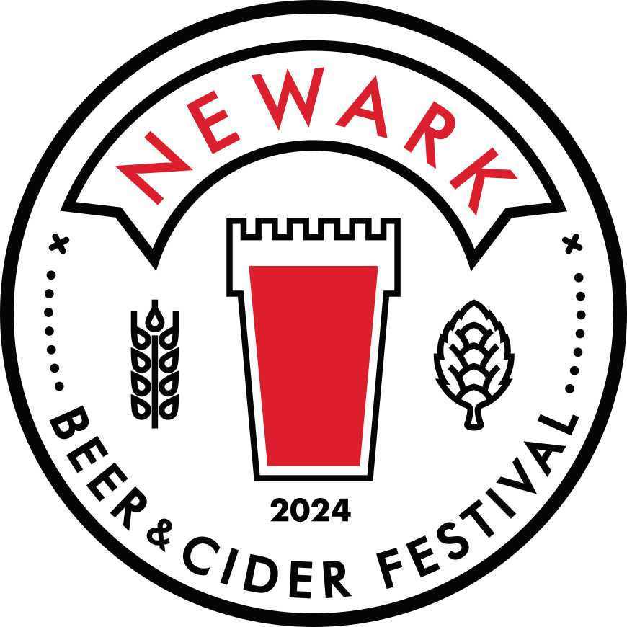

Shifts are allocated in blocks of 2 hours. We ask for a minimum of 4 hours from you, which can be either one 4 hour slot or two different 2 hour slots across the festival.
Beer tokens will be allocated in the usual way – 3 staff tokens per 2 hours worked.
After a 4 hour block you will receive a food voucher worth £5.00. (max. 2 per day).

NAME:

EMAIL:

PHONE:

CAMRA MEMBERSHIP NO:

Have you volunteered at the Newark Beer Festival before: YES: NO:

Please mark x in the boxes below for the time and dates of the shifts you would like to do.

We also need help with the set up on Wednesday 22nd and Thursday 23rd May. Please mark x if you can help with this.
WEDNESDAY 22/05 9am onwards – THURSDAY 23/05 10am onwards –
And lastly for the take-down on MONDAY 27/05 from 10am –

PLEASE NOTE: ANYONE HELPING WITH SET UP AND TAKE DOWN MUST WEAR STEEL TOE-CAPPED FOOTWEAR.
Newark CAMRA will subsidise £15.00 per person to purchase a pair.

SHIFT HOURS | FRI 24/05 | SAT 25/05 | SUN 26/05
12:00 – 14:00
14:00 – 16:00
10:30 – 12:30
12:30 – 14:30
14:30 – 16:30
16:30 – 18:30
18:30 – 20:30
20:30 – 22:30
Are you willing to work anywhere? - Beer bar, Cider bar, Tokens, Door, Membership. YES: NO:

If not please state preferences:

PLEASE NOTE: BAR STAFF MUST WEAR ENCLOSED FOOTWEAR BEHIND THE BAR.
SANDALS AND FLIP FLOPS WILL NOT BE ALLOWED.

We will supply a free festival T-shirt to be worn whilst working. Please mark x in the appropriate box for shirt size.

Small |  | Medium |  | Large |  | X Large |  | XX Large

Please email completed forms back to staffing@newarkcamra.org.uk
Or post to: 74 Harcourt Street, Newark NG24 1RF.

Sam Lucas (Beer Festival Organiser) 07967 204634

